Student Hardware Contest

  - May 2022
  - Version 0.10


Symposiuminfo@smcss.org





Mohammad Kameli
Researcher, KU Leuven, Belgium
Zhao Chen
Researcher, KU Leuven, Belgium
Pavithrakrishnan Radhakrishnan
Researcher, KU Leuven, Belgium

Student Hardware Design Team 2022

Document Revisions

Date | Version Number | Document Changes
05/20/2022 | 0.1 | Initial Draft
06/20/2022 | 0.3

Table of Contents
1 Introduction 5
1.1 Start of activity 5
1.2 Contest schedule (general draft) 5
1.3 Topic criteria 5
1.3.1 Pool of ideas 5
1.4 Jury committee 6
1.4.1 Evaluation criteria 6
1.4.2 Jury members selection 6
1.5 Flyer example (2022, see Appendix A) 6
2 Student hardware design 2022 7
2.1 Jury members for 2022 7
2.1.1 A few Instructions for the Judgement 7
2.2 Received videos 7
2.3 Evaluation sheet (Appendix B) 7
2.4 Dissemination 7
2.4.1 Introduction video 7
2.4.2 Social media post context 7
3 Appendices 9
3.1 Flyer (Appendix A) 9
3.2 Evaluation sheet (Appendix B) 10

Introduction

Start of activity
- EdCom committee lead Prof. dr. ir. Frank Leferink encouraged PhD students to take part in EdCom activities where Student hardware (HW) contest was also involved.
- Mr. Pavithrakrishnan Radhakrishnan, Mr. Mohammad Kameli and Mr. Zhao Chen from KU Leuven Bruges campus, Belgium volunteered to take up the challenge.
- A few inputs about the organisational part of the HW contest were given
- Prof. Todd Hubing was the instructor of the PhD organizing team.
- Previous year’s flyer was shared

Contest schedule (general draft)
- Enrolment: from the 1st week of January every year (after New year) (until?)
- Deadline to submit videos: the last week of April (preparation time will last until the easter break)
- Notification of winners: June 17th, 2022 (considering the jury evaluation notification is fixed in June)
Note: but for the next year, due to the summer breaks and award list notification, we should declare the contest during the last week of May. Also, it will be more practical for winners to book flight tickets as soon as possible.
- Top 3 finalists will be listed in the conference program. (General procedure)
- Winning entries: August 4th, 2022, will be recognized at the Awards Luncheon IEEE EMC + SIPI 2022
(Each year symposium occurs in the last week of July or the 1st week of August. So, usually awards luncheon should be on the 4th day of the symposium)

Topic criteria
- Usually, it is a problem-solving contest.
- Considering the Covid-pandemic, the local organising team discussed with the coach (Dr. Todd) and finalised the contest to be an educational merit video contest, focusing on EMC, SI, PI and/or related hardware topics
- No software simulations are allowed, but the video can include 90% HW and 10% SW simulation (can be used for validation)

Pool of ideas
Each of the volunteer shared topics could be useful for the theme of the symposium
Since this is the first year after the pause due to covid, any fundamental topic (open choice) could be given
- Trade-off of LED display quality and EMC compliance?
  - Mark Steffka (University of Detroit mercy US)
- Do not let interference ruin your projects
  - Alistair Duffy (DMU UK)
- Based on the Symposium location topics can be chosen “Automotive EMC” Since Michigan is the venue for IEEE EMC + SIPI 2023
  - Pavithrakrishnan Radhakrishnan (KU Leuven Bruges)
- Basic design with conducted / radiated emission constraints
- High Voltage Design to tackle EMC issues

Jury committee

Evaluation criteria
- Technical design (35%)
- Creativity (35%)
- Educational merit (30%)

Jury members selection
- Senior (Life member EMC Member)
- Young professional (YP) member
- Professor at university
- EMC Engineer
- Early-stage researcher (optional)

Flyer example (2022, see Appendix A)

Student hardware design 2022

Jury members for 2022
- Vignesh Rajamani (IEEE EMC S President)
- Johan Catrysse (Life senior member)
- Robert Vogt (professor at university)
- Patrick De Roy, ADI (Engineer at ADI)

A few Instructions for the Judgement
- Evaluation Criteria: technical design (35%), creativity (35%), and educational merit (30%). Total points are 100.
- All the videos should be about hardware demonstrations, not software simulations. Please be strict in this aspect of judging!
- Final decision will be based on the cumulative average of all the jury members.

Received videos
- TU Graz – Austria
- KU Leuven Brugge campus - Belgium (2 videos)
- University of Colorado – USA
- Poznan University of Technology – Poland
- Missouri University of Science and Technology - USA

Evaluation sheet (Appendix B)

Dissemination

Introduction video
- Context preparation
- Shooting
- Edit and release

Social media post context
- Example 1:
Interested in Electromagnetic Compatibility (EMC) or Signal/Power Integrity(SIPI) of hardware design?
Willing to show your presentation talent to the public with your own entertaining and educational videos?
Wants to win prizes in a professional contest?
Then why not join our 2022 Student EMC Hardware Design Contest? Targeting for EMC Hardware Design, we're looking for student teams to show their creative skills of EMC/SIPI, intending to disseminate EMC/SIPI knowledge to the public in a more intuitive and interesting way. This amazing contest will provide you not only a floor to show your excellent ideas, but also a chance get guidance from our EMC/SIPI experts. So what are you waiting for? Just go to our official website (https://emc2022.emcss.org/student-emc-hardware-design-competition.html) to find out the details! Now!
We're looking forward to seeing you and your masterpiece in the contest!
- Example 2:
Do you know “Black magic”? Have you ever been impressed by the powerful black wizard? Are you willing to be an "electronic black wizard"? Now your dream may come true!
In real life, Electromagnetic Compatibility (EMC) and Signal/Power Integrity (SIPI) are always considered by lots of people as "black magic". To show the secret of "black magic" and help more peers to learn how to deal with them, we're organizing the 2022 Student EMC Hardware Design Contest. In such a "multi-wizard" contest, targeting for EMC Hardware Design, you and your scientific “wizard team” will be able to showcase your excellent skills and in-depth understandings of EMC/SIPI, get valuable guidance from our experts, as well as winning wonderful prizes. Should you need more information, please go to our official website (https://emc2022.emcss.org/student-emc-hardware-design-competition.html) We're right there, waiting for your amazing show!

Appendices

Flyer (Appendix A)
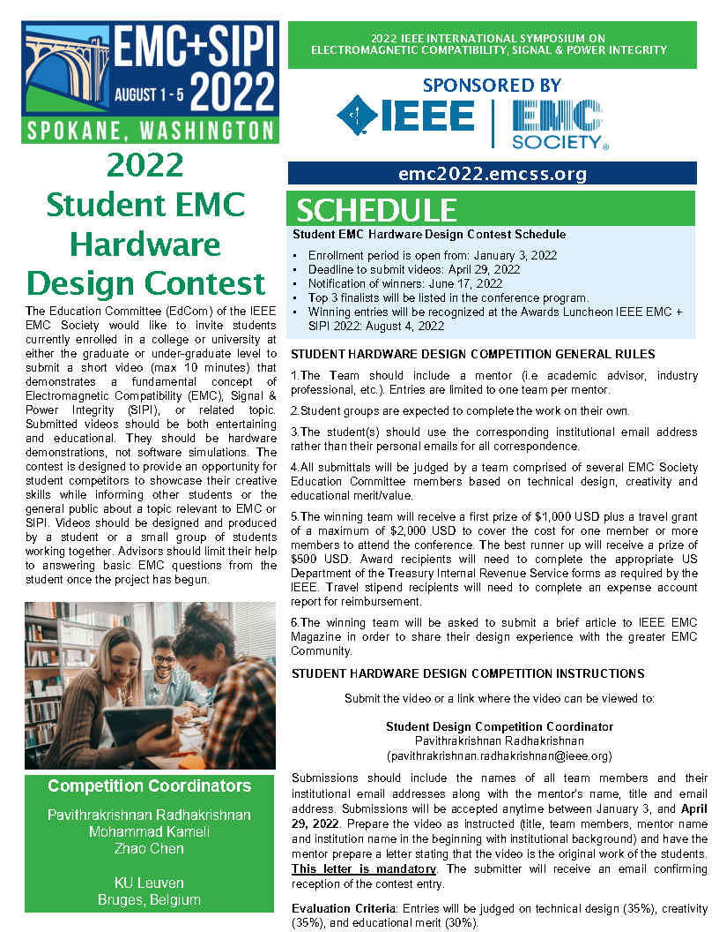

Evaluation sheet (Appendix B)
